Name ______________ Homework!
Write your parents a letter to persuade them to attend math night on Tuesday, October 25, 2016 at 6:00 p.m. here at Parker!

*Look at the copy of the permission slip sent home to get ideas on how to convince your parents to go
1.There will be pizza and fun activities
2.They will learn how to do the math that you are doing
3. They will meet teachers and other parents (read the permission slip for more ideas)
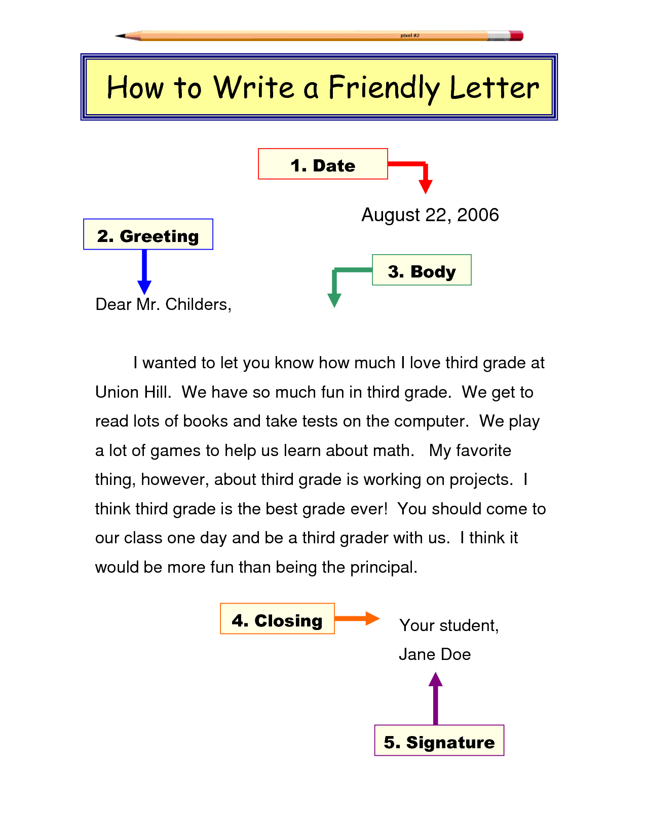
*BE NEAT! You want your parents to see your best spelling, grammar, and penmanship!

Example of format:

*write yours on
the back ->

